**Linear Search Algorithm (Sequential Search)**

**What is Search?**

Search is a process of finding a value in a list of values. In other words, searching is the process of locating given value position in a list of values.

**Linear Search Algorithm (Sequential Search Algorithm)**

Linear search algorithm finds given element in a list of elements with **O(n)** time complexity where **n** is total number of elements in the list. This search process starts comparing of search element with the first element in the list. If both are matching then results with element found otherwise search element is compared with next element in the list. If both are matched, then the result is "element found". Otherwise, repeat the same with the next element in the list until search element is compared with last element in the list, if that last element also doesn't match, then the result is "Element not found in the list". That means, the search element is compared with element by element in the list.

**Linear search is implemented using following steps...**

**Step 1:** Read the search element from the user

**Step 2:** Compare, the search element with the first element in the list.

**Step 3:** If both are matching, then display "Given element found!!!" and terminate the function

**Step 4:** If both are not matching, then compare search element with the next element in the list.

**Step 5:** Repeat steps 3 and 4 until the search element is compared with the last element in the

list.

**Step 6:** If the last element in the list is also doesn't match, then display "Element not found!!!" and terminate the function.

**Example**

Consider the following list of element and search element...

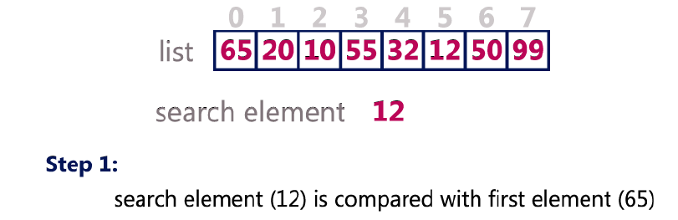

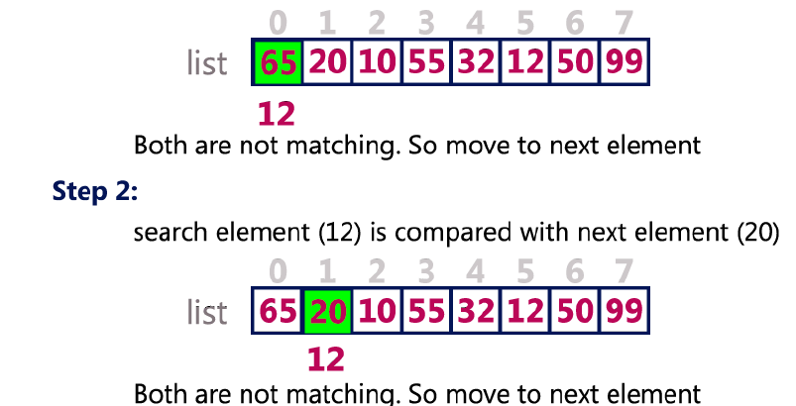

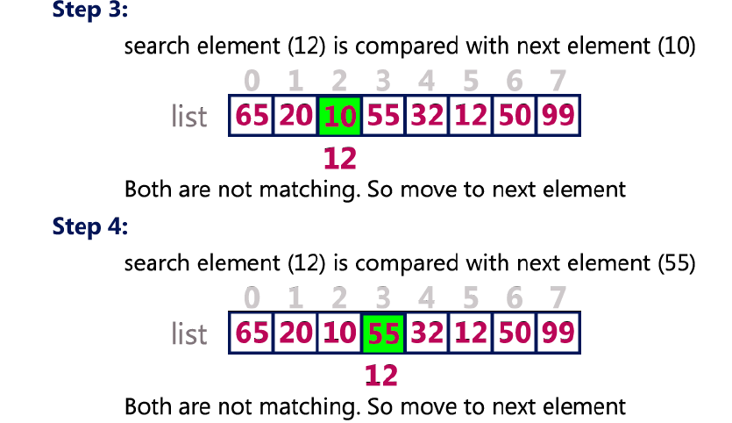

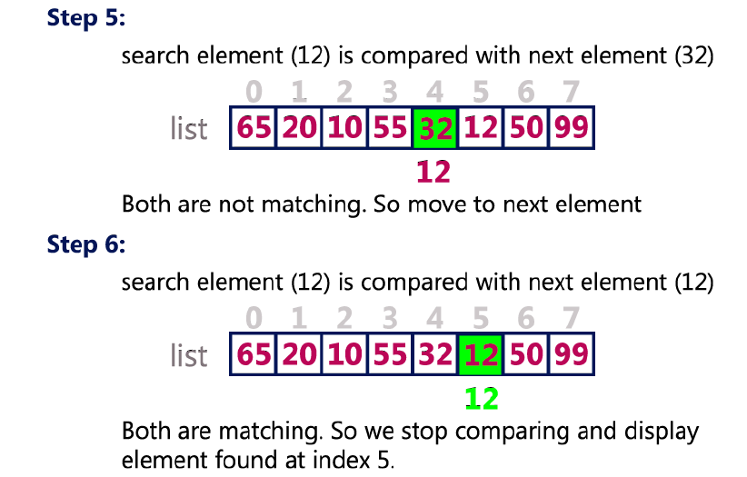

**Linear Search Program in C Programming Language**

#include<stdio.h>

#include<conio.h>

void main()

{

int list[20],size,i,sElement;

printf("Enter size of the list: ");

scanf("%d",&size);

printf("Enter any %d integer values: ",size);

for(i = 0; i < size; i++)

scanf("%d",&list[i]);

printf("Enter the element to be Search: ");

scanf("%d",&sElement);

// Linear Search Logic

for(i = 0; i < size; i++)

{

if(sElement == list[i])

{

printf("Element is found at %d index", i);

break;

}

}

if(i == size)

printf("Given element is not found in the list!!!");

getch();

}